Venue ~ 2018 ARYA National Championships

WHERE TO FIND US Montrose Bay Yacht Club
Foreshore Road,
Rosetta Tasmania 7010

(See alternative route to venue below)

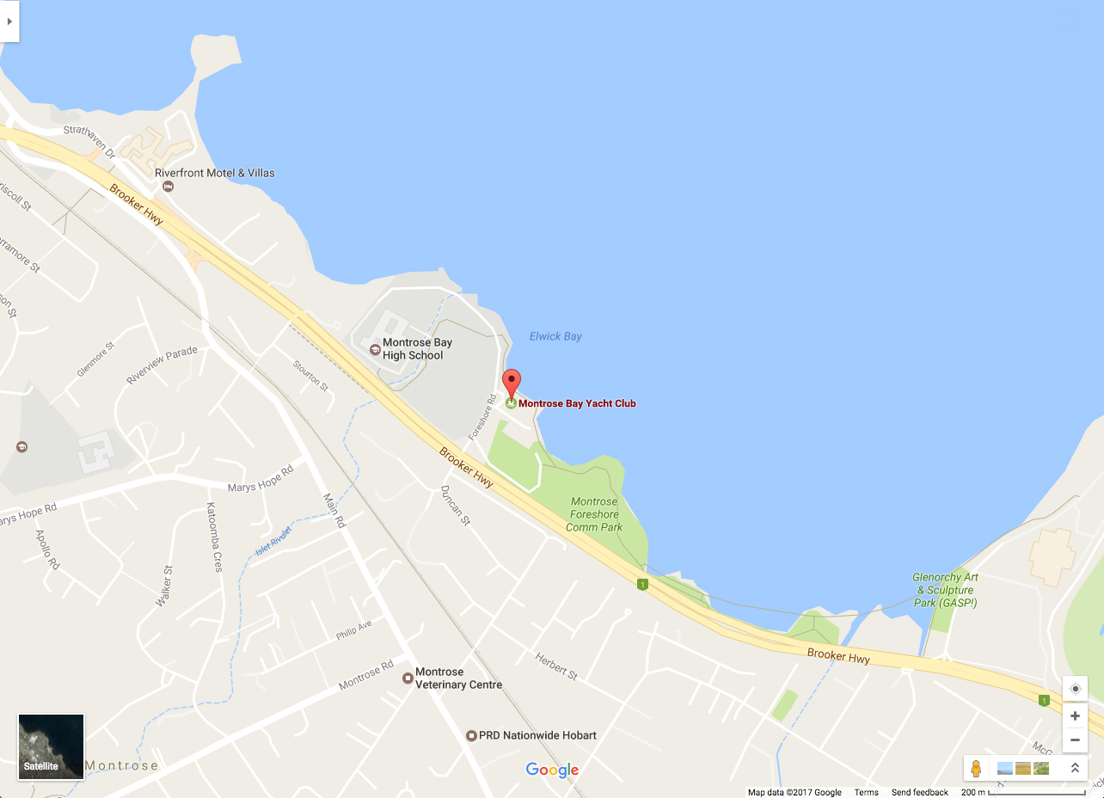
Decimal coordinates (latitude, longitude): -42.8244760,147.2957180
GPS Position: 147°17'44"E, 42°49'28"S

MONTROSE BAY YACHT CLUB
Montrose Bay Yacht Club is situated on the foreshore of the western side of the River Derwent, set within public parklands & five minutes from the Glenorchy shopping & commercial precinct.
The clubhouse contains toilets, change & shower rooms, a kiosk, meeting rooms & a large general dining area & wet bar. Secure boat storage areas are available.
Launching of boats is via two sets of steps; one at the end of MBYC jetty, the other on the southern parkland foreshore.

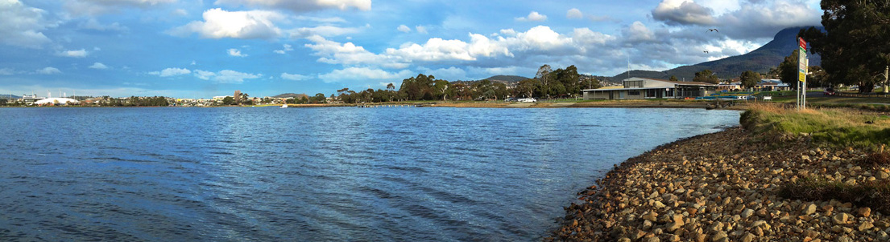

RECOMMENDED ALTERNATIVE ROUTE TO VENUE.



